Yes. If you want Grand Store to operate a professional, high-trust auction platform for rare and exclusive whisky, I would build it more like a specialist auction house + secure marketplace, rather than simply adding an “Auction” button to an e-commerce site.
For South Africa in particular, online auctions are subject to the Consumer Protection Act (CPA), its auction regulations, and electronic-commerce requirements. The regulations specifically address internet auctions, bidder registration, security, records and auction rules.
1. The basic Grand Store auction model
The cleanest structure is:
SELLER → GRAND STORE AUCTION HOUSE → VERIFIED BIDDERS → WINNING BIDDER → PAYMENT → DELIVERY → SELLER PAYOUT
Grand Store acts as the trusted intermediary.
For an exclusive whisky auction, I would have three separate accounts:
Seller account
The seller:
- Registers and completes KYC
- Proves ownership/right to sell
- Uploads whisky details
- Provides photographs
- Provides provenance/authenticity documentation
- Specifies reserve price
- Agrees to auction terms
- Ships/consigns the whisky to Grand Store, or uses an approved custody arrangement
- Receives payout after successful completion
Bidder/buyer account
The buyer:
- Registers
- Confirms age
- Provides ID/passport
- Provides address
- Provides payment details
- Accepts auction rules
- Receives a bidder number
- Deposits/authorises a payment guarantee if required
- Bids
- Pays if successful
- Receives the whisky
Grand Store administrator
Grand Store:
- Verifies sellers
- Verifies whisky
- Approves lots
- Creates auction
- Controls bidding
- Monitors suspicious behaviour
- Collects buyer payment
- Organises delivery
- Releases seller payment
- Maintains records
- Handles disputes

2. The most important principle: don't allow anyone to bid immediately
For expensive whisky, registration should not equal bidding approval.
I would create:
REGISTERED → KYC CHECK → AGE CHECK → PAYMENT VERIFICATION → RISK CHECK → APPROVED BIDDER
Only then does the "Place Bid" button become active.
South African online-auction regulations require prospective internet bidders to register with information including their full name, ID/passport number, age, physical address, IP address and payment method.
So your developer should build a proper Bidder Verification Engine, not merely a normal customer registration.

3. Seller flow
Imagine someone wants to sell a 1960s Macallan.
Step 1 — Seller submits whisky
Seller enters:
- Brand
- Distillery
- Expression
- Year
- Bottling year
- Bottle size
- ABV
- Bottle number
- Cask number, if applicable
- Limited edition information
- Condition
- Fill level
- Box/tube condition
- Provenance
- Purchase history
- Country of origin
- Current location
- Reserve price
- Estimated value
Then uploads:
- Front photograph
- Back photograph
- Bottle photograph
- Capsule
- Seal
- Bottle number
- Box
- Receipt
- Certificate
- Provenance documentation

4. Grand Store authenticates the whisky
This is critical for a premium whisky auction.
Do not allow:
"Seller says it's genuine → upload → auction."
Instead:
Authentication status
Each lot should have a status:
Pending Verification
→ Documents Verified
→ Physical Inspection
→ Authenticity Approved
→ Auction Approved
→ Auction Live
For extremely valuable bottles, Grand Store could require physical inspection before accepting the lot.
For example:
R5,000 bottle: documentation + photographs may be sufficient depending on policy.
R100,000 bottle: physical inspection strongly recommended.
R500,000+ bottle: specialist authentication/custody should be considered.

5. Create a professional "Lot"
Every bottle becomes a LOT, not simply a product.
Example:
LOT #GS-2026-00127
Macallan 25 Year Old — Rare Release
- Bottle: 750ml
- ABV: 43%
- Distillery: Macallan
- Bottled: xxxx
- Bottle No: xxxx
- Condition: Excellent
- Box: Original
- Provenance: Verified
- Authentication: Grand Store Approved
- Starting Bid: R50,000
- Reserve: R65,000
- Auction Opens: 10 September 2026
- Auction Closes: 17 September 2026
- Buyer Premium: 15%
This makes the platform feel like a real auction house, rather than a normal online shop.

6. Reserve price
I would give sellers three options:
No Reserve
Highest valid bidder wins.
Reserve
Seller specifies a confidential minimum price.
Example:
Starting bid: R50,000
Reserve: R65,000
If bidding reaches R62,000:
Reserve not met.
If bidding reaches R65,000:
Reserve met.
From that point, the highest valid bidder wins when the auction closes.
The CPA requires advance disclosure where an auction is subject to a reserve/upset price.

7. Starting price vs reserve
This is an important distinction your developer needs to understand.
Starting price ≠ reserve price.
Example:
 | Amount
Starting bid | R30,000
Reserve | R50,000
Current bid | R42,000
Reserve status | Not met
Next minimum bid | R43,000
Once:
Current bid = R50,000
the system displays:
🟢 RESERVE MET

8. Bidding mechanics
The system should automatically control increments.
For example:
Current price | Minimum increment
R1,000–R4,999 | R250
R5,000–R9,999 | R500
R10,000–R49,999 | R1,000
R50,000–R99,999 | R2,500
R100,000+ | R5,000
The exact structure is your business decision.
The bidder sees:
Current Bid: R75,000
Next Bid: R77,500

9. Consider proxy/maximum bidding
This is extremely useful.
A bidder can say:
"I am willing to go up to R150,000."
They don't have to sit on the website all evening.
The system automatically bids on their behalf:
Bidder A maximum: R150,000
Bidder B maximum: R110,000
The system might progressively bid:
R100k → R102.5k → R105k → etc.
Bidder A only pays enough to beat the competition, subject to your rules.
This makes the auction much more professional.

10. Auction closing — use an anti-sniping rule
This is one of the biggest protections I would recommend.
Suppose an auction closes at:
20:00
Someone bids at:
19:59:59
The auction should not necessarily immediately close.
Instead:
Last-minute bid detected. Auction extended by 2 minutes.
If another bid arrives:
Extended again by 2 minutes.
This prevents someone from winning purely because they submitted a bid milliseconds before closing.
You can call this:
"Fair Close / Dynamic Extension"

11. The winning bidder
When the auction ends:
Congratulations!
You are the winning bidder for Lot #GS-2026-00127.
Then show:
Winning Bid: R100,000
Buyer's Premium: R15,000
VAT: where applicable
Delivery: R1,500
Total: R116,500
The customer gets a fixed payment deadline.
For example:
Payment due within 24 hours.
Don't allow:
"I'll pay next week."
For high-value auctions, payment discipline is essential.

12. Buyer's premium
This is how many professional auction models make money.
Example:
Winning bid:
R100,000
Buyer premium:
15% = R15,000
Buyer subtotal:
R115,000
Plus applicable VAT/taxes/delivery.
You need to clearly disclose the buyer's premium before the person bids.
Your auction rules should also explain exactly how commissions, fees, taxes and delivery charges work.
South African auction regulations require written auction rules and prescribe minimum information that those rules must contain.

13. Seller commission
You can also charge the seller.
For example:
Hammer price: R100,000
Grand Store seller commission:
10% = R10,000
Seller receives:
R90,000
You therefore potentially have:
Buyer revenue
15% buyer premium = R15,000
Seller revenue
10% seller commission = R10,000
Grand Store gross auction revenue
R25,000
You obviously need to structure this carefully with your accountant and legal advisers, particularly regarding VAT and the exact agency/sale structure.

14. Don't necessarily release seller money immediately
For expensive whisky, I would use:
BUYER PAYMENT → FUNDS VERIFIED → DELIVERY → DELIVERY CONFIRMED → SELLER PAYOUT
rather than:
BUYER PAYS → SELLER GETS MONEY
This protects everyone.
The auction regulations also contain rules concerning auctioneers holding/accounting for consumer property and seller agreements.

15. Very important: seller should not necessarily ship directly to buyer
For your premium whisky auction, I would seriously consider a controlled custody model.
Preferred model
Seller
↓
Grand Store / approved bonded or licensed facility
↓
Authentication
↓
Auction
↓
Buyer pays
↓
Grand Store releases shipment
↓
Licensed delivery
↓
Buyer
This gives Grand Store much greater control over:
- Authenticity
- Condition
- Stock
- Insurance
- Delivery
- Disputes
- Counterfeit prevention
You should have specialist South African liquor/legal advice on the licensing and custody structure because liquor distribution must comply with applicable liquor legislation and licensing requirements. The DTIC states, for example, that liquor may only be distributed to registered persons/entities or other licensees under the applicable National Liquor Authority framework.

16. How to stop fake bidders
This is probably the most important part of your question.
I would implement 10 layers of bidder protection.
Layer 1 — Identity
Require:
- Full name
- ID/passport
- Date of birth
- Address
- Mobile number
- Email
Layer 2 — Age
Whisky auction:
18+ only, with appropriate age verification.
Layer 3 — Mobile verification
OTP.
Layer 4 — Email verification
Verification link.
Layer 5 — Payment verification
Verify card/payment method.
Layer 6 — Deposit / bidding authorisation
For expensive auctions:
"To participate in this auction, a refundable R10,000 bidding deposit is required."
Or use payment pre-authorisation where technically and legally appropriate.
Layer 7 — Risk scoring
The system looks for:
- Multiple accounts
- Same IP
- Same device
- Same card
- Same phone
- Same address
- Unusual bidding patterns
- Rapid account creation
- Multiple failed payments
- Previous defaults
Layer 8 — Manual approval
For high-value lots:
Bidder approval required
Layer 9 — Maximum exposure
Don't let a new bidder suddenly bid:
R2 million
without appropriate verification.
You could establish:
Standard verified bidder: R25,000 limit
Enhanced bidder: R250,000
Premium bidder: R1m+
based on verification and financial/payment checks.
Layer 10 — Default history
Create a permanent internal:
Bidder Reliability Score
For example:
98/100 — Excellent
75/100 — Good
42/100 — Restricted

17. Stop shill bidding
This is absolutely essential.
Shill bidding means somebody artificially increases the price.
Example:
Seller owns bottle.
Seller creates another account.
Seller bids against genuine buyers.
That is extremely dangerous for an auction platform.
Your system should monitor relationships between:
Seller ↔ Bidder
including:
- IP addresses
- Devices
- telephone numbers
- addresses
- payment information
- account history
- bidding patterns
If suspicious:
🚨 Potential Related Bidder Detected
Send it to an administrator.
South African auction law specifically restricts seller/owner bidding unless the relevant right is properly disclosed, and the CPA provides consequences where undisclosed owner bidding occurs.

18. Stop fake accounts
I would prohibit:
One person = multiple active bidder accounts
The system should detect:
Same ID
Same mobile
Same payment method
Same device
Same address
Same IP
and flag duplicates.
Do not necessarily automatically ban based on IP alone because households, corporate networks and VPNs can create false positives.
Use multiple signals.

19. Protect against bots
Your developer should implement:
- CAPTCHA / bot detection
- Rate limiting
- API protection
- Login throttling
- Device fingerprinting
- Suspicious activity monitoring
- WAF/security controls
- Bid-frequency limits
For example:
A normal bidder might make:
5 bids in 10 minutes.
A bot could make:
500 requests per second.
That should trigger protection.

20. Every bid must be logged
This is extremely important.
Your database should permanently record:
Bid ID
Auction ID
Lot ID
Bidder ID
Bid amount
Timestamp
IP address
Device/session information
Previous bid
Auction status
Reserve status
Bid accepted/rejected
You want an immutable auction audit trail.
The South African regulations require prescribed auction records to be retained for at least three years.
I would personally retain much longer where legally appropriate and commercially useful.

21. The bidder must see their history
In their dashboard:
My Auctions
Lot 127
Your maximum bid: R150,000
Current bid: R125,000
Status: 🟢 Winning

If somebody beats them:
🔴 You've been outbid
Current bid: R127,500
Bid again
This keeps the auction engaging.

22. Seller dashboard
The seller should see:
My Lots
Lot | Status | Current Bid | Reserve | Bids
Macallan 25 | Live | R75,000 | R80,000 | 18
Yamazaki 25 | Live | R120,000 | R100,000 | 31
Springbank | Sold | R45,000 | R40,000 | 24
But be careful about showing bidder identities to sellers. Use bidder numbers/anonymous identifiers rather than exposing personal information.

23. Grand Store Admin Dashboard
I would make the auction administrator dashboard extremely powerful.
Auction Control Centre
LIVE AUCTIONS: 27
PENDING LOTS: 42
PENDING SELLER KYC: 8
PENDING AUTHENTICATION: 11
PAYMENTS PENDING: 5
DELIVERIES: 9
DISPUTES: 2
SUSPICIOUS ACCOUNTS: 4

Fraud alerts
🚨 Multiple accounts detected
🚨 Seller/bidder relationship detected
🚨 Unusual bidding pattern
🚨 Payment failure
🚨 Multiple failed registrations
🚨 High-value bid requiring manual approval

24. The auction lifecycle
I would give every auction a strict status.
DRAFT
↓
SELLER SUBMITTED
↓
SELLER VERIFIED
↓
LOT AUTHENTICATED
↓
AUCTION APPROVED
↓
SCHEDULED
↓
PREVIEW
↓
LIVE
↓
EXTENDED (if last-minute bidding)
↓
CLOSED
↓
PAYMENT PENDING
↓
PAYMENT VERIFIED
↓
DISPATCHED
↓
DELIVERED
↓
BUYER ACCEPTED
↓
SELLER PAYOUT
↓
COMPLETED
This should be built directly into the database and backend.

25. What happens if the winner doesn't pay?
You need extremely clear rules.
Example:
Payment deadline: 24 hours
If unpaid:
- Account suspended
- Bidding privileges suspended
- Deposit retained where legally permissible and according to the published rules
- Seller notified
- Lot marked Defaulted
- Grand Store decides whether to offer to the next bidder or re-auction, according to its rules and applicable law.
The rules must be carefully drafted by your lawyer rather than simply copied from another auction site.

26. What happens if the seller doesn't deliver?
Similarly:
Seller default
→ Seller account suspended
→ Buyer refunded according to applicable rules
→ Seller potentially liable for applicable costs/damages
→ Seller reliability score reduced
→ Future selling privileges restricted
The auction regulations specifically address situations where goods aren't delivered and impose obligations on auctioneers.

27. International buyers
This can become a major part of Grand Store's premium auction business.
The checkout should determine:
Buyer country
↓
Can this liquor legally be delivered there?
↓
Applicable import restrictions
↓
Duties/taxes
↓
Shipping
↓
Insurance
↓
Final landed cost
The buyer should see:
Hammer price
- Buyer premium
- applicable VAT
- shipping
- insurance
- applicable taxes/duties
= Estimated total
But do not promise international delivery merely because a courier can technically carry the bottle. Alcohol importation is highly jurisdiction-specific.

28. VAT/accounting needs to be built into the auction
This is where your accounting background becomes important.
Don't record everything simply as:
"Online sale R100,000."
Your accounting system should distinguish:
Hammer price
Buyer premium
Seller commission
VAT
Shipping
Insurance
Payment gateway fee
Currency conversion
Refund
Deposit
Grand Store revenue
Seller payable
That way the auction ledger reconciles automatically.

29. Example complete transaction
Let's say:
Rare whisky
Hammer price:
R100,000
Buyer premium 15%:
R15,000
Applicable VAT/tax:
calculated according to the transaction structure
Shipping:
R1,500
Buyer pays:
R116,500 + applicable taxes/VAT
Grand Store then calculates:
Hammer price: R100,000
Less seller commission 10%: R10,000
Seller payout:
R90,000
Grand Store's auction revenue:
R25,000
before applicable VAT, payment fees and other costs.
This is the kind of transaction that should automatically generate buyer invoice + seller statement + Grand Store accounting entry + auction audit record.

30. Your legal "Auction Rules" are critical
Before somebody can bid:
☑ I have read and accepted the Rules of Auction.
The rules should cover:
- Eligibility
- Age requirement
- Registration
- KYC
- Bidder deposits
- Bidding procedure
- Starting bid
- Reserve
- Bid increments
- Proxy bidding
- Auction closing
- Extension rules
- Buyer's premium
- Seller commission
- VAT
- Payment deadline
- Default
- Cancellation
- Delivery
- Insurance
- Authenticity
- Inspection
- Returns/disputes
- Fraud
- Shill bidding
- Multiple accounts
- Suspension
- Privacy
- International buyers
- Customs/import duties
- Governing law
South African regulations require auction rules to be compiled in writing and made available in advance, subject to the applicable auction type.

31. One thing I would change about a normal Grand Store marketplace
Do not combine the normal marketplace and premium auction logic into one simple checkout.
Create a separate:
GRAND STORE AUCTIONS
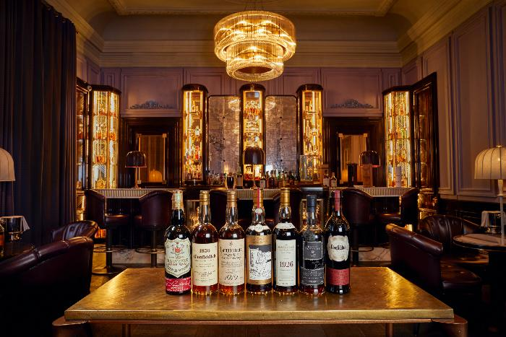
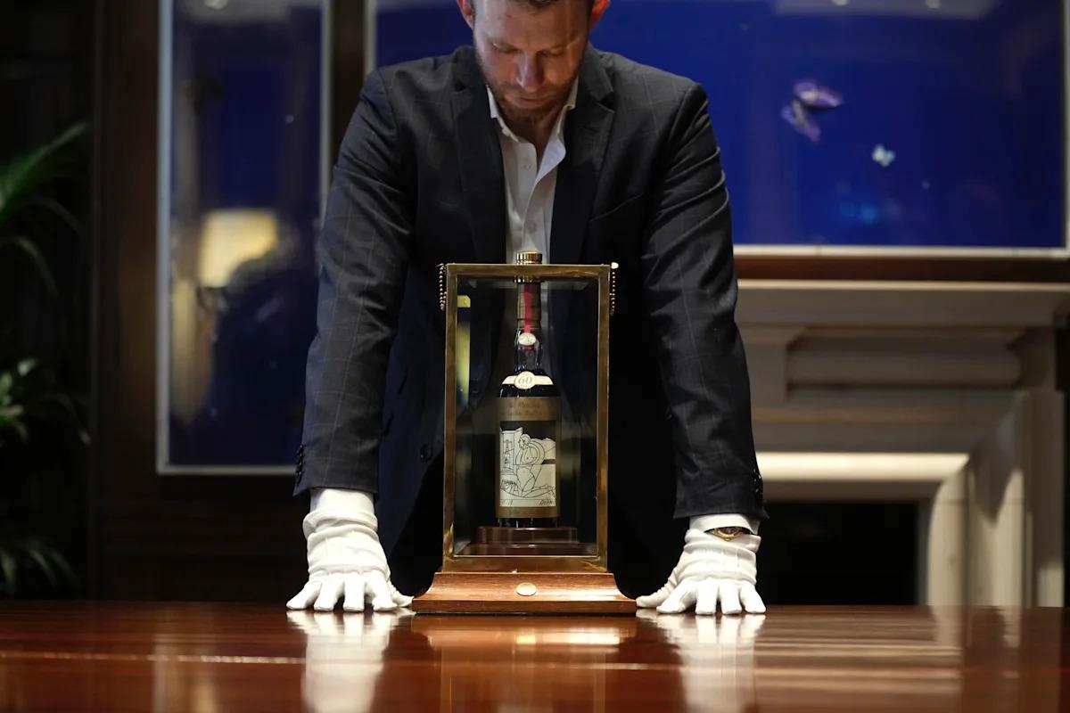
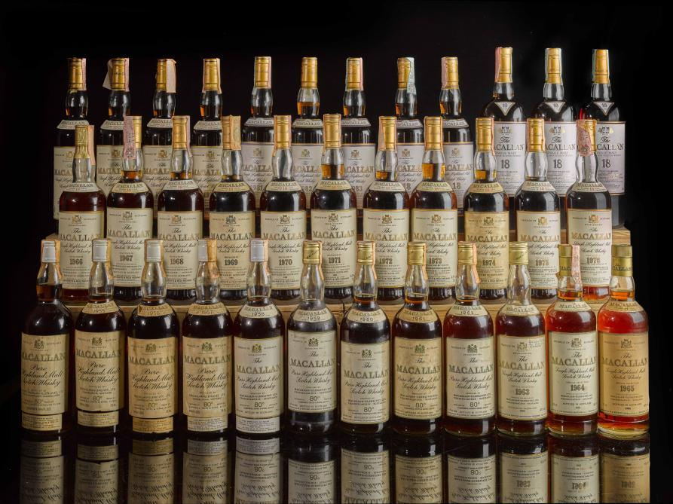
7
With:
Live Auctions | Upcoming | Results | Sell Whisky | How It Works
Then make it feel exclusive.
For example:
GRAND STORE RARE WHISKY AUCTIONS
Rare bottles. Exceptional provenance. Trusted bidding.

32. The ideal overall architecture
I'd build the system as:
GRAND STORE AUCTIONS
│
┌─────────────┴─────────────┐
│ │
SELLERS BUYERS
│ │
KYC/KYB KYC + AGE
│ │
Whisky Submission Bidder Approval
│ │
Authentication Deposit/Payment
│ │
└─────────────┬─────────────┘
│
LOT CREATION
│
AUCTION ENGINE
│
┌────────────┼────────────┐
│ │ │
Live Bids Reserve Fraud Engine
│ │ │
└────────────┼────────────┘
│
AUCTION CLOSES
│
WINNING BIDDER
│
PAYMENT
│
PAYMENT VERIFIED
│
DELIVERY
│
BUYER CONFIRMS
│
SELLER PAYOUT
│
ACCOUNTING
│
AUDIT TRAIL
33. My recommended revenue model for Grand Store
For a premium platform, I'd consider:
Seller
- Listing fee: optional
- Seller commission: 8–15%
- Premium/authentication fee for exceptional bottles: optional
Buyer
- Buyer's premium: 10–20%
- Delivery
- Insurance
- Applicable taxes/VAT
Grand Store
- Seller commission
- Buyer premium
- Authentication services
- Premium listing/featured auction
- Storage/custody fees
- International logistics margin where appropriate
The exact percentages should be commercially tested and legally/accounting-checked.

34. The five things I would NOT compromise on
If you're building this for Grand Store, I would make these non-negotiable:
1. Verified sellers
No anonymous sellers.
2. Verified bidders
No anonymous high-value bidding.
3. Authenticity
No expensive bottle goes live without appropriate verification.
4. Money control
Payment must be verified before the transaction proceeds to completion/payout.
5. Complete audit trail
Every bid, change, login, payment and administrative action must be recorded.
That combination is what will make people trust Grand Store with a R50,000, R100,000 or R1 million bottle.
One additional point is particularly relevant in South Africa: the National Liquor Authority has introduced QR-code and online licence verification for NLA certificates issued from 18 February 2026, specifically as a security measure against fraudulent certificates. That is something I'd incorporate into your seller/licence verification process where applicable.

